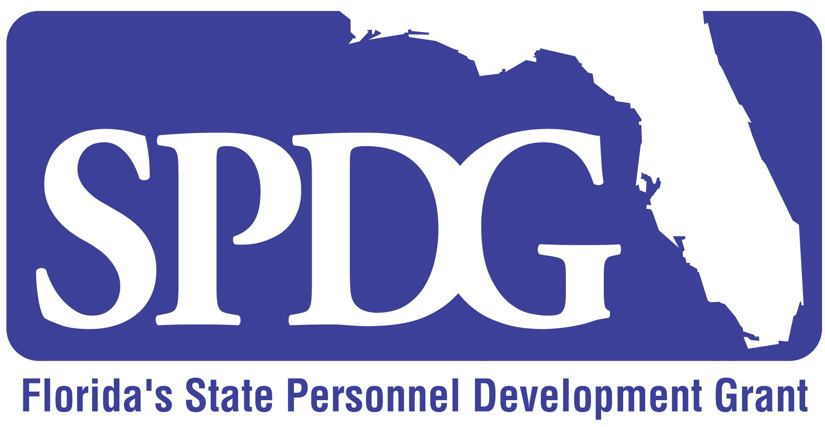
Check and Connect Project
  - District & School Responsibilities

LEA Supervisor Responsibilities
- Represent the LEA and its interests in implementation of the site action plans with fidelity
- Oversee the work of the school teams
- Participate in Check and Connect trainings
- Select a team at each participating school site (School Site Team) to include school site administrator, general and exceptional student education representatives, student services personnel, dropout prevention personnel/graduation coach and Check and Connect lead mentor or coordinator
- Ensure appropriate school site personnel participate in Check and Connect orientations and trainings and encourage continued professional development as appropriate in subsequent years
- Provide clear expectations that trained personnel implement Check and Connect program
- Support the delivery of orientations to Check and Connect for families in collaboration with parent organization subcontractor and develop and implements plans to ensure parent involvement with Check and Connect efforts
- Ensure schools meet reporting deadlines and provide required data
- Provide access to district and state level student performance data and ensures the implementation of data collection activities accurately and consistently as defined in the action plan
- Meet quarterly with the Check and Connect Project Manager
- Develop a district plan for sustaining Check and Connect implementation by the middle of the second year of implementation
- Review district policies and procedures for general and exceptional education to ensure they are consistent with Check and Connect implementation

School Site Team Responsibilities
- Include school principal or designee as a member of the team
- Compile and review student data related to drop out, graduation, and proficiency rates for students with IEPs
- Develop a School Site Action Plan, oversee implementation of the plan, and monitor results
- Develop a Communication Plan for sharing outcomes and process with stakeholders
- Establish student eligibility criteria for Check and Connect
- Identify Check and Connect Mentors and assign caseloads
- Ensure access of the Mentors have time and access to eligible students and families
- Assist in collection of data concerning fidelity of implementation
- Participate in in Check and Connect training (4 days)
- Meet monthly with the Check and Connect Project Manager to review implementation, data, adjusting strategies as needed
- Conduct a quarterly review of data and submit to Check and Connect Project Manager and LEA Supervisor

Mentor Responsibilities
- Attend Check and Connect Implementation and Mentor Training (2 days year 1) and annual Refresher Blasts (1 day)
- Work with the Lead Mentor/Coordinator , Check and Connect Project Manager and Institute for Community Integration, Univ. of Minn. personnel to increase personal proficiency in the delivery of Check and Connect program components (activities may include on-site or virtual coaching and modeling, or video reflection)
- Maintain a Check and Connect monitoring sheet for each student on caseload
- Implement C & C according to site action plan and providing personalized interventions and targeted strategies, based on check data, to meet the needs of the students on the mentor’s caseload.
- Complete an anonymous online survey regarding the school site administrator’s demonstration of support for the initiative.

Student Responsibilities
- Participate in Check and Connect program, meet with assigned Mentor and participate in daily problem solving and goal setting.
- Collect and monitor personal data as appropriate per individual
- Complete satisfaction survey

