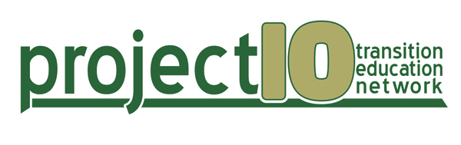

January 11, 2012

TO: Region 5 ESE Directors
Region 5 School District Transition Contacts
Region 5 Center for Autism and Related Disorders (CARD) Transition Contacts
Region 5 Florida Diagnostic & Learning Resources System (FDLRS) Transition Contacts
Region 5 Florida Inclusion Network (FIN) Facilitators
Region 5 Project 10 CONNECT Site Coordinators
Region 5 SEDNET Project Managers
Region 5 Division of Vocational Rehabilitation Area Directors
Region 5 State/University Directors of Disability Services

SUBJECT: Project 10: Transition Education Network Region 5 Winter Institute

Project 10: Transition Education Network, in cooperation with the Florida Department of Education, Bureau of Exceptional Education and Student Services, is pleased to announce the Project 10 Region 5 Winter Institute. The focus of this year’s Winter Institute will be Postsecondary Options for Students with Disabilities.

This event will be held on February 7, 2012, from 9:30 a.m. to 4:00 p.m., in the Sunrise room at the Sawgrass Technology Park, located at 1643 North Harrison Parkway, Sunrise, Florida 33323. This is the Broward County School District’s South Area Office, Building H.

All meeting attendees must complete the registration form and submit it to Project 10 as soon as possible, as space is limited.

Accommodations for participants with special needs will be available upon request. To ensure appropriate accommodations during the meeting, please indicate any special requests on the registration form.

If you have any questions, please contact Lisa Friedman-Chavez, Project 10 Southern Regional Transition Representative, at (305) 964-6687, or lfchavez@mail.usf.edu; or Jordan Knab, Project 10 Director, at (727) 873-4662, or JKnab@mail.usf.edu. We look forward to seeing you at the meeting!

Enclosures

cc: Sheila Gritz
Cathy Bishop

