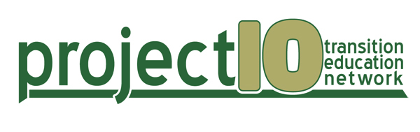
Training and Technical Assistance Handout
Key: SD: Student Development; SFP: Student Focused Planning; PS: Program Structure; IC: Interagency Collaboration; FI: Family Involvement; T: training; TA: technical assistance. Indicators 1: Graduation Rate; 2: Dropout Rate; 13: Postsecondary Goals, Transition IEP; 14: Postschool Outcomes.
Project 10 Trainings/Topics
An Introduction to Successful Grant Writing
ArtThread Work of Art Training
Building Work Skills for Employment Success: Strategies and Resources
Community Resource Mapping
Developing Quality Transition IEPs
Discovery Process for Students in Transition
- Part I: Overview of the Discovery Process in Florida
- Part II: Developing Florida Discovery Student Profiles, Representational Portfolios and Visual Resumes
- Part III: Customized Employment/Work Experience Planning Meeting and Job Development
Dropout Prevention for Students with Disabilities
- Part I: Florida’s Current Status
- Part II: Strategies for Improvement
Graduation Requirements
Introduction to Secondary Transition Planning for Students with Disabilities
Interagency Councils
- Conducting Focus Groups
- Developing Interagency Transition Teams
- Project 10 CONNECT: Project Expectations for New and Existing Sites
Job Development
Project 10, An Overview (website, resources and products)
School-Based Enterprise (SBE) Development: Planning, Implementation and Evaluation
Self-Determination and Self-Advocacy
Service Learning
Standing Up For Me (SUFM)
Students Transitioning to Adult Roles (STAR) Person-Centered Planning (PCP)
The Florida Summary of Performance (SOP): Requirements and Suggested Practices
Transition Assessment: Using Data for Transition Planning
Transition Basics: Information for Families and Others Who Support Students with Disabilities
Using School-Level Data to Increase Graduation Success with Disabilities
Using Transition Assessment Data to Write Measurable Postsecondary Goals

Online Courses
Course Topic | URL
Job Development | http://project10.info/On-LineTraining.php?PageCategory=On-line%20Training
Self-Determination
Transition Assessment
Graduation Requirements | http://pdportal.florida-ese.org/
Using Data to Increase Graduation Success

Scope and Sequence for Secondary Transition Courses
Scope and Sequence | URL
7963140 Self-Determination | http://www.project10.info/files/7963140_SelfDetermination_v5.21.15.pdf
7980040 Preparation for Entrepreneurship/  Self-Employment | Scope and Sequence links for all of the Employment Courses are available through the following:  http://project10.info/DetailPage.php?MainPageID=280
7980110 Career Preparation
7980120 Career Experiences
7980130 Career Placement
7980150 Supported Competitive Employment

